**Access your EndNote Library references Anywhere**

To access your EndNote Library from any other computer,anywhere and anytime.You need to synchronise the EndNote references on the Desktop with EndNote Web (Online version). If you add or remove references from EndNote Desktop it automatically updates EndNote Web and vice versa.

1.Register - Click the Sync button from EndNote Desktop tool bar to open the EndNote Web Login. Click the sign- up button and complete the online registration form.

http://s3.amazonaws.com/libapps/accounts/17689/images/Syn_1.PNG

2. Now you have the Account,  Click the Sync button on the toolbar.

3. Enter e-mail + EndNote Web password.

4. Enter Ok to initiate the Sync process. **NB:** please create compressed library back up and SAVE.

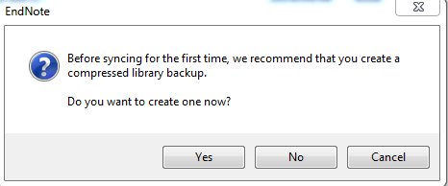http://s3.amazonaws.com/libapps/accounts/17689/images/Sync_3.PNG

4.Your references will be on the [EndNote Web](https://www.myendnoteweb.com/EndNoteWeb.html?SID=Y1eZHVqfVou2RMPaYQa&returnCode=ROUTER.Success&SrcApp=CR&Init=Yes) which you can access anywhere,anytime.

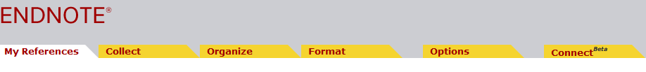

5. Sync preferences allow you to enter your credentials once not manually everytime when you Sync the references. Go to Edit on the toolbar>>Preferences>>Sync. Mark the automatic Sync box  + Apply and Ok.

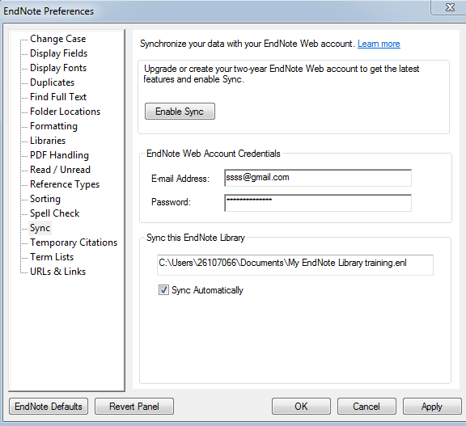

6. Using CiteWhileYouWrite (CWYW)  on  MS Word

**You can alternate between EndNote Desktop and EndNote Web**

1. Select Preferences from EndNote Desktop toolbar Click OK.

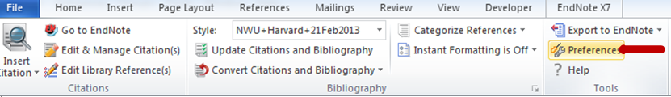

2. Go to application and Select EndNote Web.

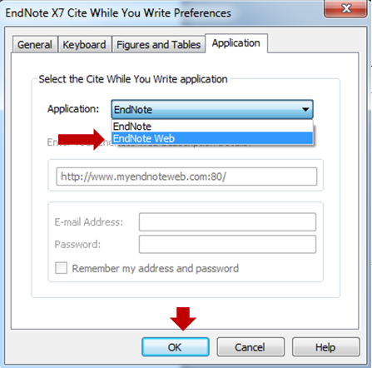

3. The EndNotex7 Toolbar will change to EndNote Web, then insert citation from EndNote Web.

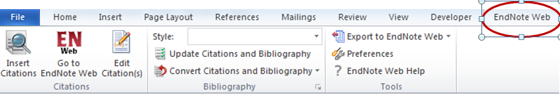

**How to email EndNote Library**

1. Open EndNote Library.

2. Select File + scroll down to select Compressed Library(.enlx).

3. Select Create & E-mail  then choose the references you want to e-mail, press Next.

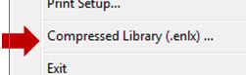   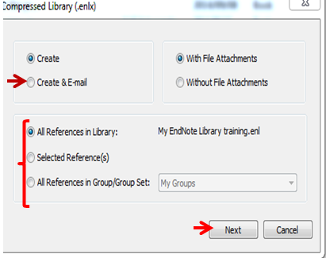

4. Rename the file +  Save EndNote Compressed Library (Automically after saving you will be required to enter e-mail address).

5. **Please Note :** You can only  E-mail the compressed library to another EndNote User.

http://s3.amazonaws.com/libapps/accounts/17689/images/Comp_3.PNG

**Use of acronyms in in-text citation**

When citing a document authored by an organization/ association /corporate body e.g **World Trade Organisation**, **World Health Organisation**, **North-West University** etc., we normally use an acronym **(WTO)** in the in-text citation. The full name of the organization and the acroynm should appear in the reference list. e.g **WTO (World Trade Organisation)**

How to use acronym in in-text citation:

1. Insert the acroynm and the full name of the reference in your EndNote Library as WTO (World Trade Organisation),,

2. Insert citation to your document.

3. Click on the in-text citation e.g **(WTO (World Trade Organisation), 2015)**.

4. Select **Edit & Manage citation(s)** option on the EndNote toolbar.

5. On the Editing box, go to **formatting** option and select **Exclude author.** e.g**(2015).**

6. Add the the acronym manual e.g **WTO (2015) OR** acronym at the **Prefix** box, enter comma and space after the comma e.g **WTO, space.** The result will be **(WTO, 2015).**

7. Click on **OK** to close the **Edit Citation(s)** window.

Blibliography: WTO (World Trade Organisation).  2015.  Understanding the World Trade Organisation.  https://www.wto.org/english/thewto_e/whatis_e/tif_e/fact1_e.htm Date of access: 08 Oct 2015.

**Bibliography on every section**

1.**EndNote**: Go to Edit and Select Output styles. Click on the style to Edit.

http://s3.amazonaws.com/libapps/accounts/17689/images/Edit.PNG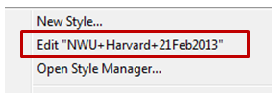

2.Go to File , Click Save As -  Copy  and Save.

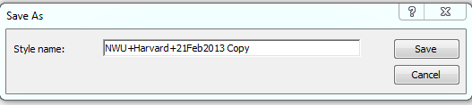

3.On the output style fields select **Sections** + Select a bibliography for each section and **Save**.

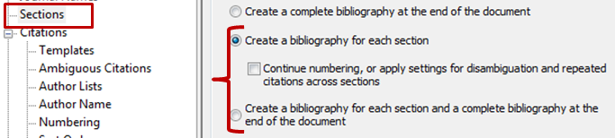

4.Open  your MS word research document +  on page layout select section breaks > e.g. Continous.

5.On Ms Word Click on EndNote, change the style to the edited copy e.g "**NWU+Harvard+21 Feb2013 Copy** ". Then you should be able to see references on each section. ([Download files for the NWU Harvard Style](http://efundi.nwu.ac.za/access/content/group/ca1f8484-4d90-4e0c-8492-1fe2d615b945/EndNote/NWU%20Harvard%2011May2015.ens))

**Combine Chapters and Create one bibliography**

If you are writing Thesis chapters in separate Word documents, you can combine chapters into a single document and have one bibilography at the end.

Method.

1.Create a copy of each chapter you wish to combine and keep the original as a backup

2.Open each copy and from EndNote X7 tab Select **Convert Citations and Bibliography > Unformatted Citations**

3.In-text references will be converted to the unformatted version e.g {Dupree, 2011 #3}

4.Copy both chapter into a new Word document

5.Reformat the new document by selecting Update Citations and Bibliography

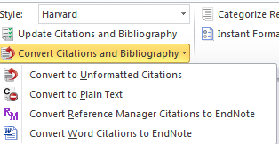

**Creating Stand- alone bibliography**

1.Open your  EndNote Library

2. Highlight references of your choice

3. Right click  and select Copy Formatted

4.Open a new Word document  + Paste

**Create references from PDF**

Many students keep PDF folders on the flash disk OR hard drive. If the PDF has DOI (Digital Object Identifier) you do not have to search databases for individual articles to export to EndNote. **NB:** PDF's without DOI you still need to search on OneSearch or Ebscohost Databases.

EndNote can import a folder or file with PDF's, trace it online and automatically create references for it.

To import go to:

1.FILE > Import. Search for your PDF folder or File.

2.Import Options> Select  Folder or File.

3.At duplicates >select discard duplicates and import.

4.If prompted to enter your user name & password, please do so.

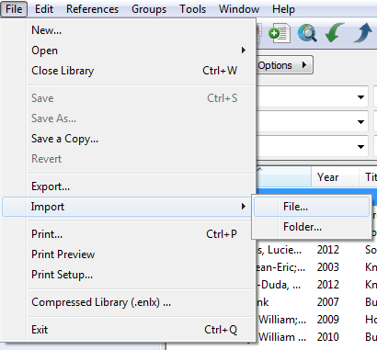      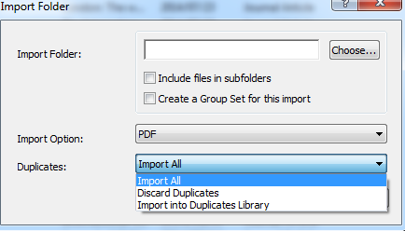

**How to change/save a new referencing style**

Obtain NWU Harvard Style from eFundi or Request it from the Librarian. **Please Note**: You need to have EndNote installed on your computer to be able to SAVE the NWU Harvard referencing style file.

STEPS: **How to download the NWU Harvard style**

Double Click on the NWU Harvard Style file

EndNote toolbar click on **File** and select **SAVE** or **SAVE AS**

STEPS: **How to change the referencing style**

On Endnote Library toolbar click on the output style

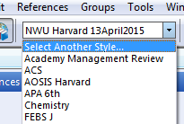

**Select another style:** NWU Harvard or any referencing style of your choice

On the dialogue window > Select the required output styles e.g NWU Harvard Style or APA 6th  and press **Choose**.

* Last Updated: Jun 21, 2017 12:20 PM
* URL: http://libguides.nwu.ac.za/citation-tools
* [Print Page](javascript:%20window.print();)

[Login to LibApps](https://nwu-za.libapps.com/libapps/login.php?site_id=1272&target64=L2xpYmd1aWRlcy9hZG1pbl9jLnBocD9nPTEwMjMyMyZwPTMyNzE0NTA=)

[Report a problem.](mailto:elize.vaneldik@nwu.ac.za)

Subjects: [Research Support](http://libguides.nwu.ac.za/sb.php?subject_id=9835)

Tags: [bibliographic management](http://libguides.nwu.ac.za/srch.php?tag=bibliographic%20management&default_lg=1), [endnote](http://libguides.nwu.ac.za/srch.php?tag=endnote&default_lg=1), [reference management](http://libguides.nwu.ac.za/srch.php?tag=reference%20management&default_lg=1)